Hr Analytics Report

Technical Requirement Document

**Content**

|  |
| --- |
| 1. Introduction 03 |
| 1.1Purpose of this document 03 |
| 1. Purpose of this Project 03 |
| 1. Scope 03 |
| 1. Data Preparation 03 |
| 1. Project Execution Procedure 11 |
| 1. Flow Chart of Preparation of Data 12 |
| 1. Data Uploading Issue 13 |
| 1. Data Validation 13 |
| 1. Power BI Desktop 13 |
| 1. Data preparation and Modeling 15 |
| 1. Business Requirements 18 |
| 1. Required Calculation 20 |
| 1. Report Building 22 |

## Introduction

## Purpose of this document

The objective of this documents is to describe the HR report is an analytical method used to display human resources-related stats, insights, and metrics with the primary purpose of **improving workforce performance, recruiting procedures, and other relevant HR processes with the help of HR dashboards**.

## Purpose of this Project

## HR reports provide both quantitative and qualitative information on employees, HR practices, and company trends – and this information is vital for informed decision making. Regular HR reporting enables both HR and management to keep their fingers on the organization's pulse by tracking key workforce metrics.

## Scope

* HR analytics is a method used to create and assess insights into the workforce, to determine the contribution of every employee towards generating revenue for the organization, reducing overall costs, modifying risks, as well as accomplishing strategic plans.

# This helps you create relevant learning and development programs that help upskill and reskill your employees, boost performance, achieve organizational goals, and save time and money.

## Data Preparation

Data given by client that contains following information Data fact table: (excel file)

After data analysis and KPI identification you have to do following task,

* Load the shared  data files into oracle database as it is.
* Decide the data type for SQL table creation from the shared file which data type should be there to load data into final table with appropriate data type.
* First load data into staging table as it is and then load it into final table with right data type.

Steps:-

1. Create schema connection in oracle for the project.
2. Load the shared data file into oracle database.

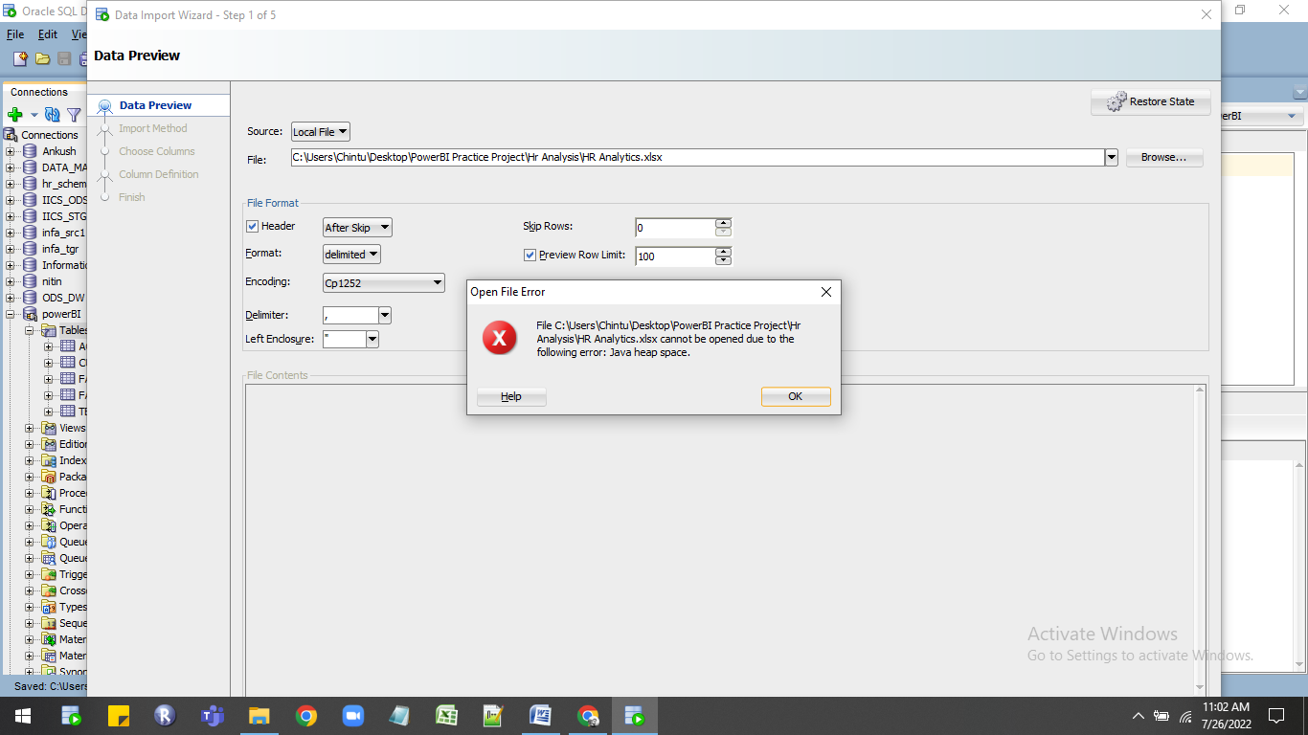

4).Get error  at the time of file load for solving that error I convert excel file into .Csv format and then load the data.

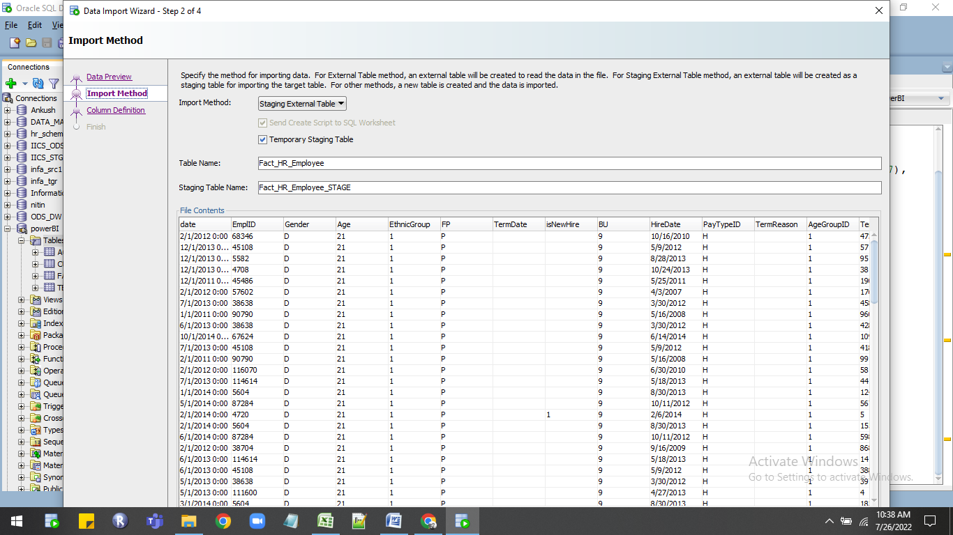

5)First load data into staging table as it is and then load it into final table with right data type.

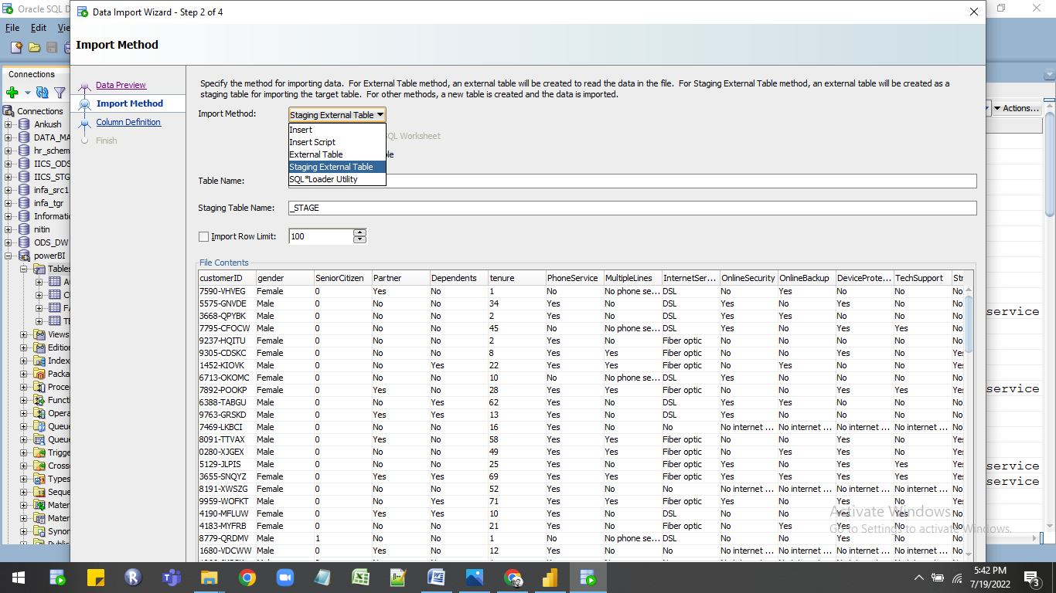

6)At the data table importing time check all the column datatypes properly.Change the date column datatype to date and column name is dates and remove space between column names.

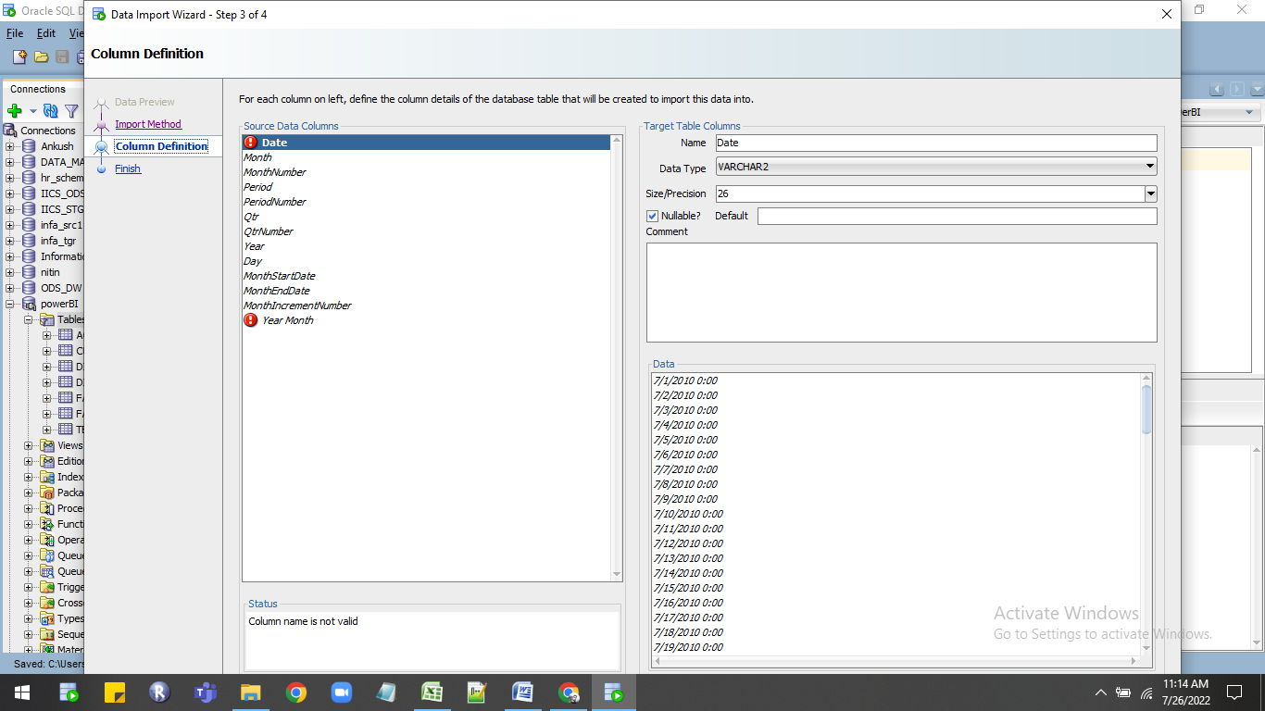

7)In data there is decimal numbers in that column so for that column use the number datatype with proper scale and precision.

* Save the data in oracle which used in power bi desktop for creating  interactive report.
* Query used in oracle.

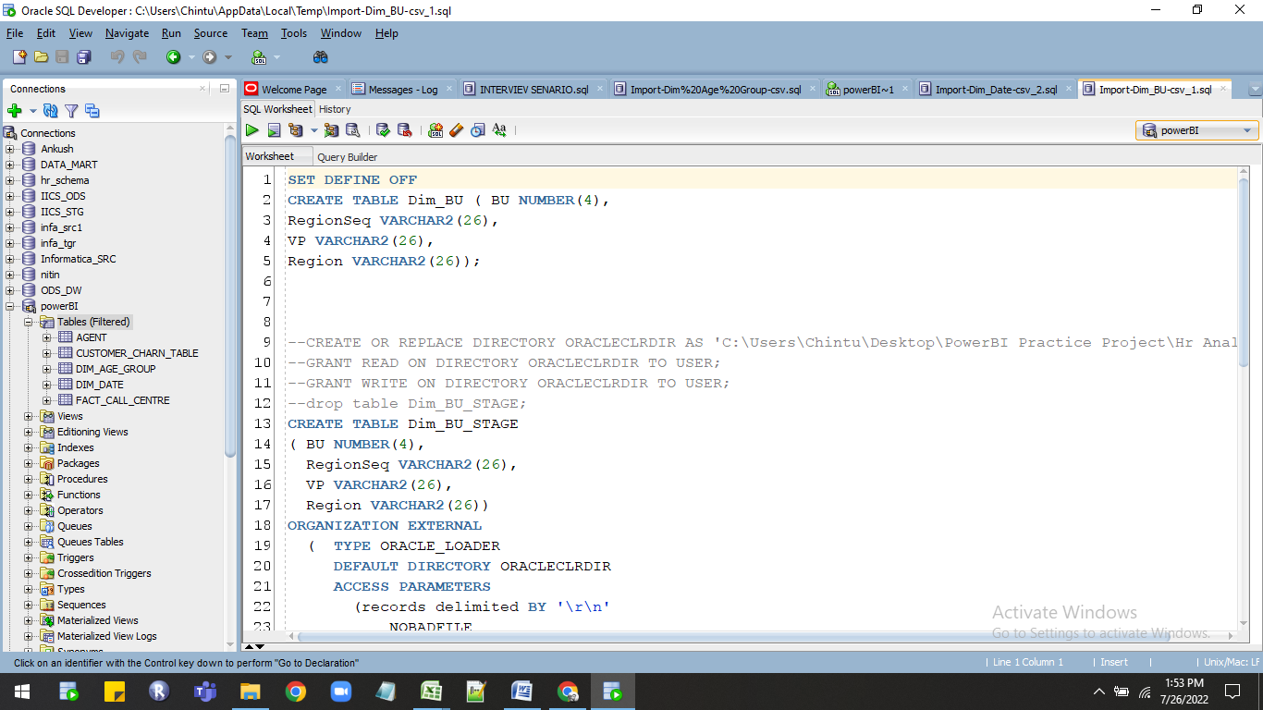

1)Staging query for Fact_employee:-

  SET DEFINE OFF

CREATE TABLE Fact_Employee ( dates DATE,

EmplID NUMBER(8),

Gender VARCHAR2(26),

Age NUMBER(4),

EthnicGroup NUMBER(3),

FP VARCHAR2(26),

TermDate VARCHAR2(26),

isNewHire NUMBER(3),

BU NUMBER(3),

HireDate DATE,

PayTypeID VARCHAR2(26),

TermReason VARCHAR2(26),

AgeGroupID NUMBER(3),

TenureDays NUMBER(6),

TenureMonths NUMBER(4),

BadHires NUMBER(3),

EmpID VARCHAR2(26));

--CREATE OR REPLACE DIRECTORY ORACLECLRDIR AS 'C:\Users\Chintu\Desktop\PowerBI Practice Project\Hr Analysis';

--GRANT READ ON DIRECTORY ORACLECLRDIR TO USER;

--GRANT WRITE ON DIRECTORY ORACLECLRDIR TO USER;

--drop table Fact_Employee_STAGE;

CREATE TABLE Fact_Employee_STAGE

( dates DATE,

  EmplID NUMBER(8),

  Gender VARCHAR2(26),

  Age NUMBER(4),

  EthnicGroup NUMBER(3),

  FP VARCHAR2(26),

  TermDate VARCHAR2(26),

  isNewHire NUMBER(3),

  BU NUMBER(3),

  HireDate DATE,

  PayTypeID VARCHAR2(26),

  TermReason VARCHAR2(26),

  AgeGroupID NUMBER(3),

  TenureDays NUMBER(6),

  TenureMonths NUMBER(4),

  BadHires NUMBER(3),

  EmpID VARCHAR2(26))

ORGANIZATION EXTERNAL

  (  TYPE ORACLE_LOADER

     DEFAULT DIRECTORY ORACLECLRDIR

     ACCESS PARAMETERS

       (records delimited BY '\r\n'

           NOBADFILE

           NODISCARDFILE

           NOLOGFILE

           skip 1

           fields terminated BY ','

           OPTIONALLY ENCLOSED BY '"' AND '"'

           lrtrim

           missing field VALUES are NULL

           ( dates CHAR(4000) date_format DATE mask "MM/DD/YYYY",

             EmplID CHAR(4000),

             Gender CHAR(4000),

             Age CHAR(4000),

             EthnicGroup CHAR(4000),

             FP CHAR(4000),

             TermDate CHAR(4000),

             isNewHire CHAR(4000),

             BU CHAR(4000),

             HireDate CHAR(4000) date_format DATE mask "MM/DD/YYYY",

             PayTypeID CHAR(4000),

             TermReason CHAR(4000),

             AgeGroupID CHAR(4000),

             TenureDays CHAR(4000),

             TenureMonths CHAR(4000),

             BadHires CHAR(4000),

             EmpID CHAR(4000)

           )

       )

     LOCATION ('HR AnalyticsEmployee.csv')

  )

  REJECT LIMIT UNLIMITED;

select * from Fact_Employee_STAGE WHERE ROWNUM <= 100;

whenever sqlerror exit rollback;

begin

  INSERT INTO Fact_Employee (dates, EmplID, Gender, Age, EthnicGroup, FP, TermDate, isNewHire, BU, HireDate, PayTypeID, TermReason, AgeGroupID, TenureDays, TenureMonths, BadHires, EmpID)

  SELECT dates, EmplID, Gender, Age, EthnicGroup, FP, TermDate, isNewHire, BU, HireDate, PayTypeID, TermReason, AgeGroupID, TenureDays, TenureMonths, BadHires, EmpID FROM Fact_Employee_STAGE ;

  COMMIT;

  EXECUTE IMMEDIATE 'DROP TABLE Fact_Employee_STAGE';

end;

/

2)Staging For Dim Date:-

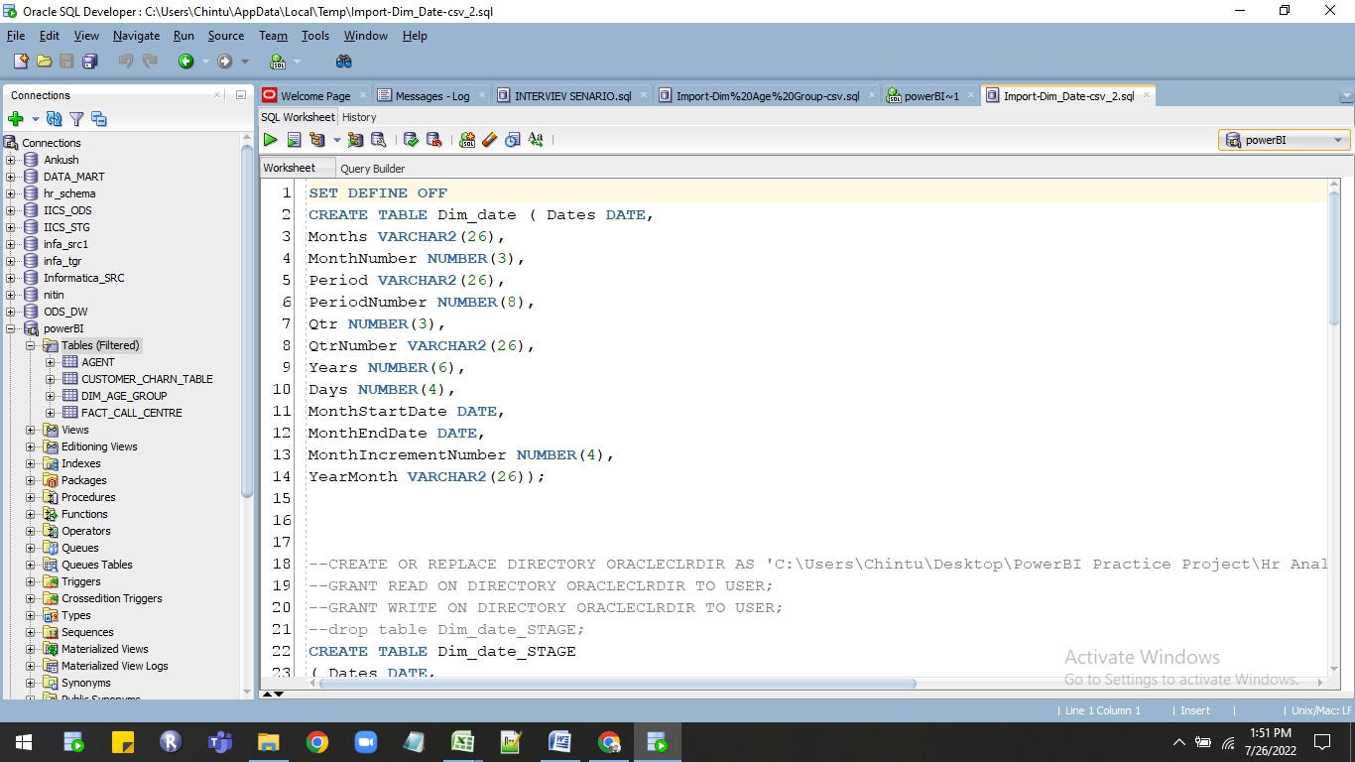

SET DEFINE OFF

CREATE TABLE Dim_date ( Dates DATE,

Months VARCHAR2(26),

MonthNumber NUMBER(3),

Period VARCHAR2(26),

PeriodNumber NUMBER(8),

Qtr NUMBER(3),

QtrNumber VARCHAR2(26),

Years NUMBER(6),

Days NUMBER(4),

MonthStartDate DATE,

MonthEndDate DATE,

MonthIncrementNumber NUMBER(4),

YearMonth VARCHAR2(26));

--CREATE OR REPLACE DIRECTORY ORACLECLRDIR AS 'C:\Users\Chintu\Desktop\PowerBI Practice Project\Hr Analysis';

--GRANT READ ON DIRECTORY ORACLECLRDIR TO USER;

--GRANT WRITE ON DIRECTORY ORACLECLRDIR TO USER;

--drop table Dim_date_STAGE;

CREATE TABLE Dim_date_STAGE

( Dates DATE,

  Months VARCHAR2(26),

  MonthNumber NUMBER(3),

  Period VARCHAR2(26),

  PeriodNumber NUMBER(8),

  Qtr NUMBER(3),

  QtrNumber VARCHAR2(26),

  Years NUMBER(6),

  Days NUMBER(4),

  MonthStartDate DATE,

  MonthEndDate DATE,

  MonthIncrementNumber NUMBER(4),

  YearMonth VARCHAR2(26))

ORGANIZATION EXTERNAL

  (  TYPE ORACLE_LOADER

     DEFAULT DIRECTORY ORACLECLRDIR

     ACCESS PARAMETERS

       (records delimited BY '\r\n'

           NOBADFILE

           NODISCARDFILE

           NOLOGFILE

           skip 1

           fields terminated BY ','

           OPTIONALLY ENCLOSED BY '"' AND '"'

           lrtrim

           missing field VALUES are NULL

           ( Dates CHAR(4000) date_format DATE mask "MM/DD/YYYY",

             Months CHAR(4000),

             MonthNumber CHAR(4000),

             Period CHAR(4000),

             PeriodNumber CHAR(4000),

             Qtr CHAR(4000),

             QtrNumber CHAR(4000),

             Years CHAR(4000),

             Days CHAR(4000),

             MonthStartDate CHAR(4000) date_format DATE mask "MM/DD/YYYY",

             MonthEndDate CHAR(4000) date_format DATE mask "MM/DD/YYYY",

             MonthIncrementNumber CHAR(4000),

             YearMonth CHAR(4000)

           )

       )

     LOCATION ('Dim_Date.csv')

  )

  REJECT LIMIT UNLIMITED;

select * from Dim_date_STAGE WHERE ROWNUM <= 100;

whenever sqlerror exit rollback;

begin

  INSERT INTO Dim_date (Dates, Months, MonthNumber, Period, PeriodNumber, Qtr, QtrNumber, Years, Days, MonthStartDate, MonthEndDate, MonthIncrementNumber, YearMonth)

  SELECT Dates, Months, MonthNumber, Period, PeriodNumber, Qtr, QtrNumber, Years, Days, MonthStartDate, MonthEndDate, MonthIncrementNumber, YearMonth FROM Dim_date_STAGE ;

  COMMIT;

  EXECUTE IMMEDIATE 'DROP TABLE Dim_date_STAGE';

end;

/

## Project Execution Procedure

## Flow Chart of Preparation of Data



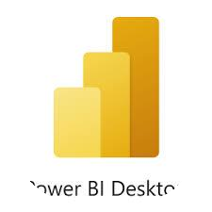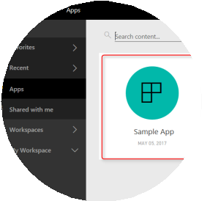

Importing Data from data source

Creation of Fact Table,Dimension Table,

Performing joins/Union all/create new table if required

Data cleaning ,Creation of Model,Dax

Calculation , Visualization like charts

,graph etc,

Publishing Report in to Power Bi Service

Creation of Apps and share to end user

## Data Uploading Issue

Convert excel file type to .Csv format.

Load the shared data file into oracle database with proper datatype for each column.

## Data Validation

* Data validation is **the practice of checking the integrity, accuracy and structure of data before it is used for a business operation**. Data validation operation results can provide data used for data analytics, business intelligence or training a machine learning model.
* Validate the data in excel in pivot table and in oracle using aggregate functions.
* Count of records in excel pivot table is 1048575.

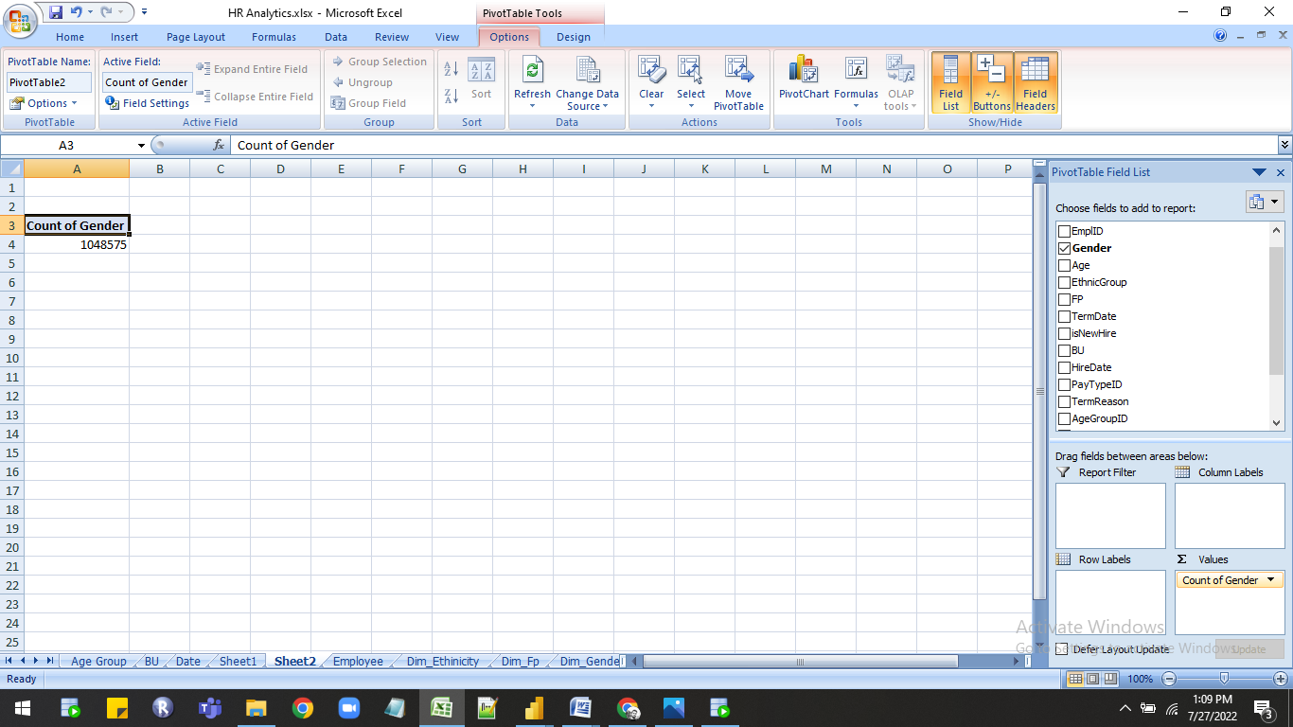

* Count of records in oracle is 1048575 used aggregate function count.

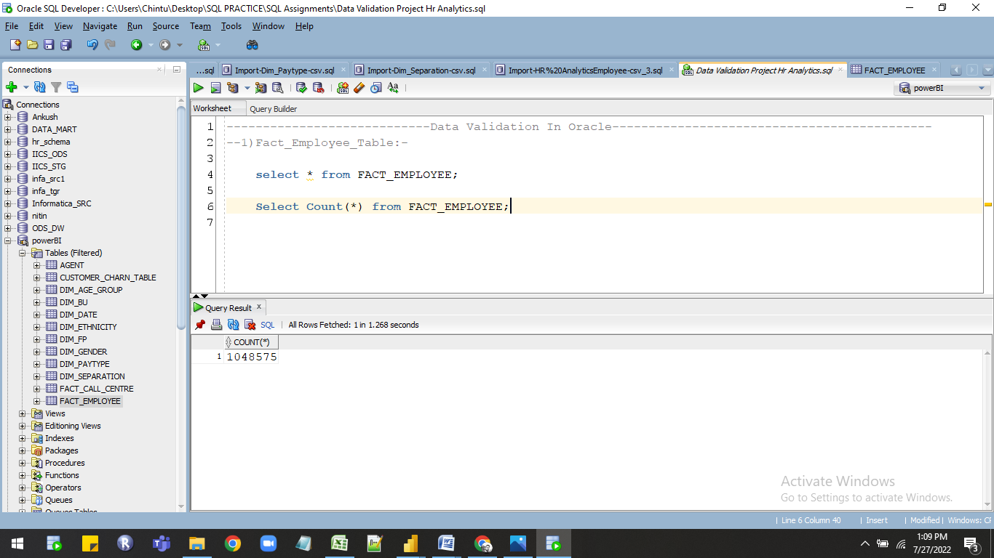

* Table showing fields which are validated in both excel and oracle.

1)Fact_Eployee Table:-

|  |  |  |  |
| --- | --- | --- | --- |
| sr.no | Fields | Excel records | Oracle records |
| 1. | Count Of Gender | 1048575 | 1048575 |
| 2. | Sum of Age | 42472996 | 42472996 |
| 3. | Average of TenureDays | 3131.983479 | 3131.983479 |
| 4. | Max of TenureMonths | 680 | 680 |
| 10. | Count Of Age | 1048575 | 1048575 |

2)Dim_Date:-

|  |  |  |  |
| --- | --- | --- | --- |
| sr.no | Fields | Excel records | Oracle records |
| 1. | Count Of Date | 2557 | 2557 |
| 2. | Sum of Day | 40224 | 40224 |
| 3. | Sum of MonthIncrementNumber | 108754 | 108754 |
| 4. | Count of Qtr | 2557 | 2557 |

3)Dim_BU:-

|  |  |  |  |
| --- | --- | --- | --- |
| sr.no | Fields | Excel records | Oracle records |
| 1. | Count Of Region | 30 | 30 |

4)Dim_Age_Group:-

|  |  |  |  |
| --- | --- | --- | --- |
| sr.no | Fields | Excel records | Oracle records |
| 1. | Count Of Agegroup | 3 | 3 |

5) Dim_Ethinicity:-

|  |  |  |  |
| --- | --- | --- | --- |
| sr.no | Fields | Excel records | Oracle records |
| 1. | Count Of ethnicity | 7 | 7 |

6) Dim_Fp:-

|  |  |  |  |
| --- | --- | --- | --- |
| sr.no | Fields | Excel records | Oracle records |
| 1. | Count Of FP | 2 | 2 |

7) Dim_Gender:-

|  |  |  |  |
| --- | --- | --- | --- |
| sr.no | Fields | Excel records | Oracle records |
| 1. | Count Of Gender | 2 | 2 |

8) Dim_Paytype:-

|  |  |  |  |
| --- | --- | --- | --- |
| sr.no | Fields | Excel records | Oracle records |
| 1. | Count Of paytype | 2 | 2 |

9) Dim_Separation:-

|  |  |  |  |
| --- | --- | --- | --- |
| sr.no | Fields | Excel records | Oracle records |
| 1. | Count Of separationtypeid | 2 | 2 |

* Quary used in oracle for data validation.

---------------------------Data Validation In Oracle--------------------------------------------

--1)Fact_Employee_Table:-

    select * from FACT_EMPLOYEE;

    Select Count(gender),sum(age),Avg(TenureDays),Max(TenureMonths)

 from FACT_EMPLOYEE;

 ---2)Dim_Date:-

     select * from Dim_Date;

     select count(dates),sum(days),sum(MonthIncrementNumber),Count(Qtr) from Dim_Date;

----3)Dim_BU:-

     select * from Dim_BU;

     select count(Region)from Dim_BU;

----4)Dim_Age_group:-

     select* from dim_age_group;

     select count(agegroup) from dim_age_group;

-----5)Dim_Ethinicity:-

     select * from Dim_Ethnicity ;

      select count(ethnicity)from Dim_Ethnicity;

-----6)Dim_Fp:-

     Select* from Dim_Fp;

     Select count(fp) from Dim_Fp;

-----7)Dim_Gender:-

     Select * from Dim_Gender;

     Select count(gender) from Dim_Gender;

-----8)Dim_Paytype:-

      Select* from Dim_Paytype;

     Select count(paytype) from Dim_Paytype;

-----9)Dim_Separation:-

      Select* from dim_separation;

      Select count(separationtypeid) from dim_separation;

## Data preparation and Modeling

* Import  data into power BI .
* Data Cleaning in power Quary.
* Create proper data model in the power BI.

**Steps :-**

1. Import the data in power BI desktop for importing data first you have to connect to oracle database.
2. To connecting data click on GET DATA option then select the DATABASE option after that select oracle database option then click on connect.

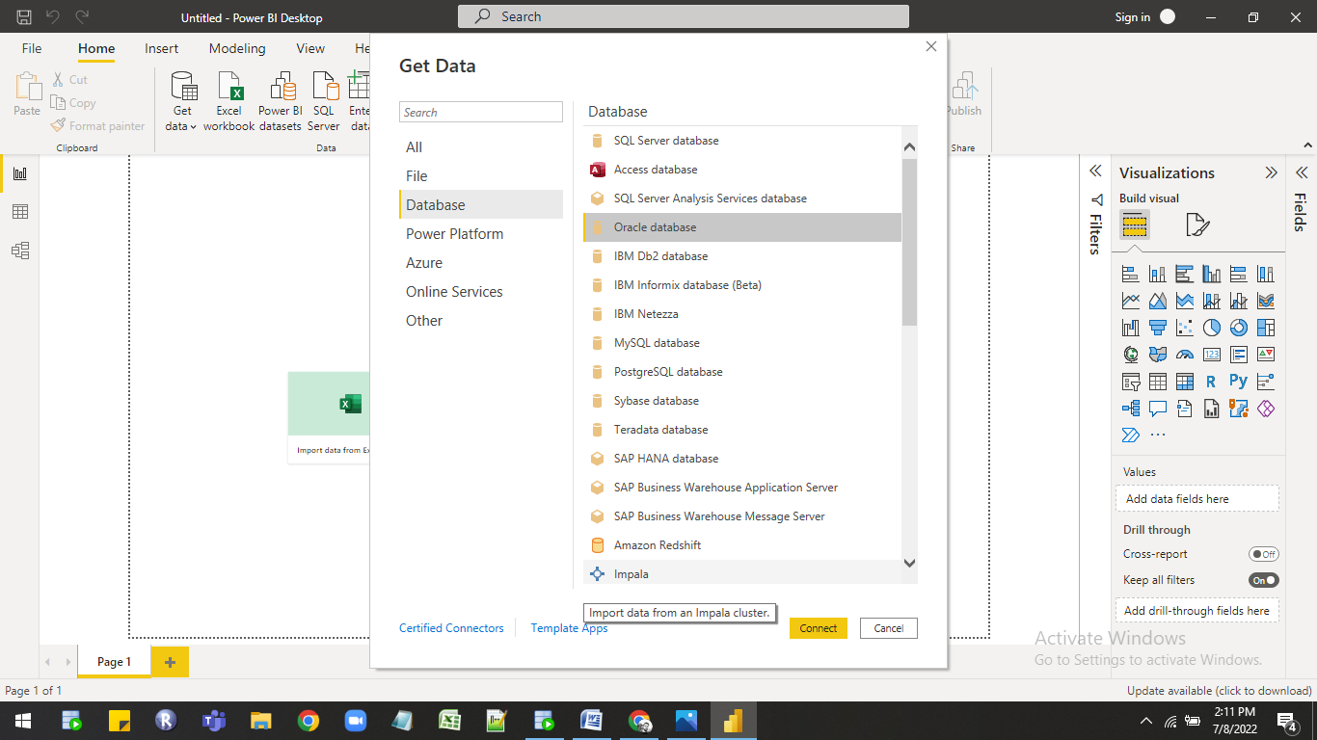

3.Then new window is open in that you have to give server name for e.g Localhost and then you have to select data connectivity mode there are two modes

* import :- file size 1gb limit.
* Direct query:- No limit for file size.

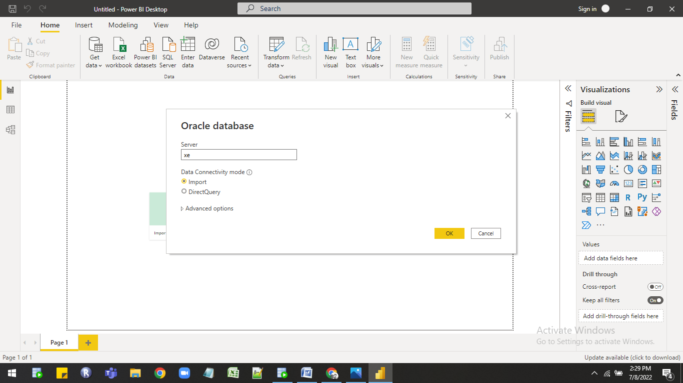

      4)Select import option then click on ok then it will connect to oracle new window open in that you can see the oracle schema with table list at left hand side from that list select the connection schema containing created tables then select whatever table you want to import in power bi they are three options

1.Load:-If you do not want any transformation in data then you can use

               Directly use load option.

2.Tranform:-Using transform option you can make changes in original dat In power quaery.

3.Cancel:- Using cancel option you can directly cancel the import.

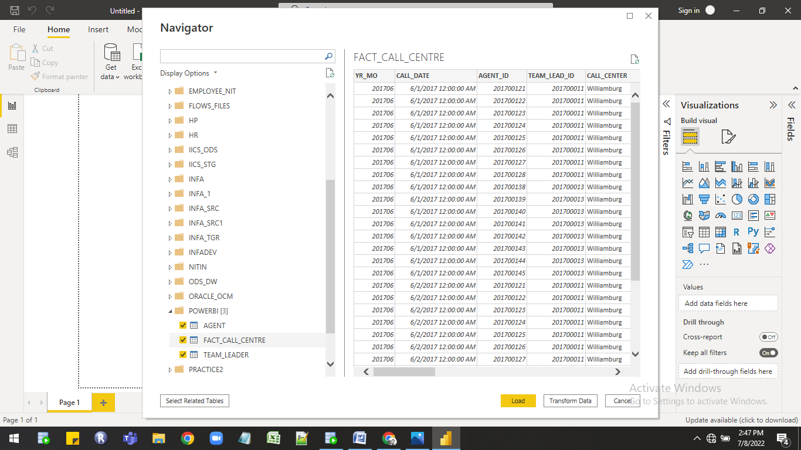

       5) Click on Tranform data option to open power  query to clean data i have check the datatypes of column.

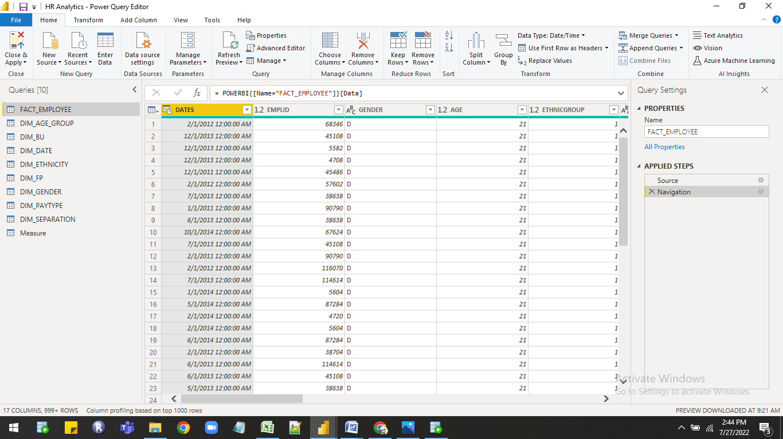

6)Click on Load option then data directly imported into power bi in power pivot stores in compressed form in columnar database vertically.

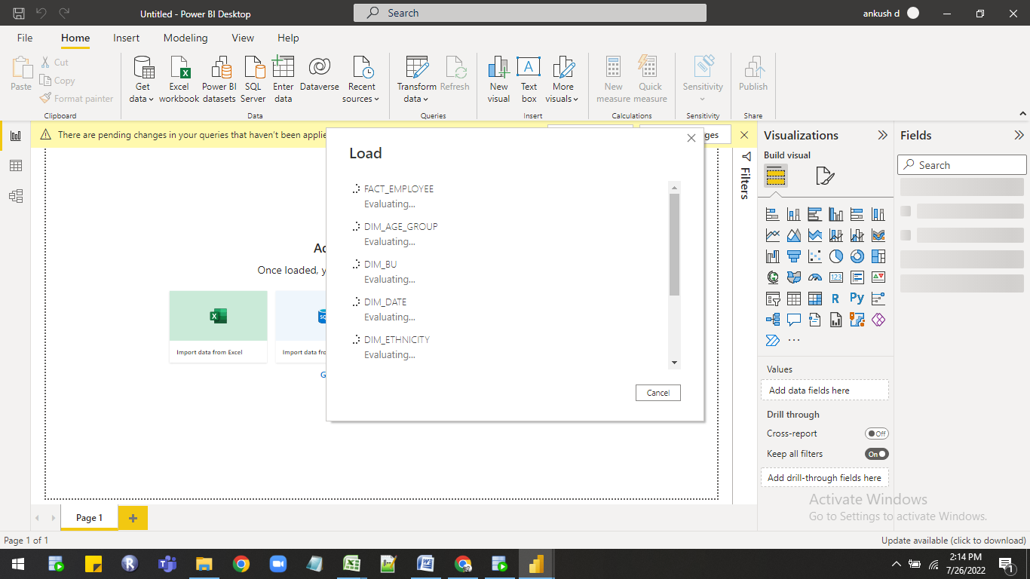

7 ) Tables is loded in power pivot click on manage relationship option for making relationship between tables.

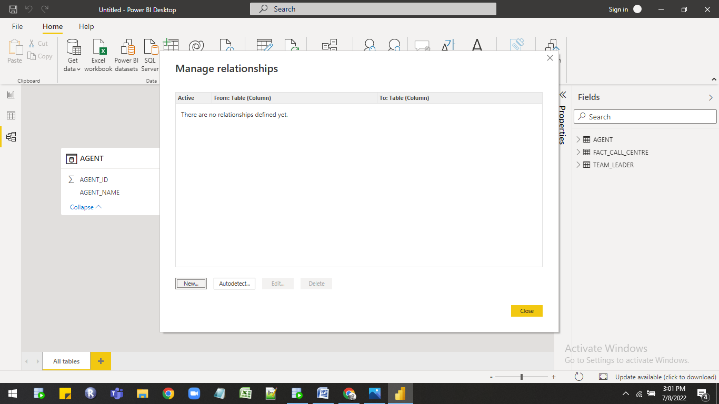

 8)Click on new option then open new window Create relationship in that select tables and columns that are related then check the cardinality and then check filter direction then click on ok at the end.

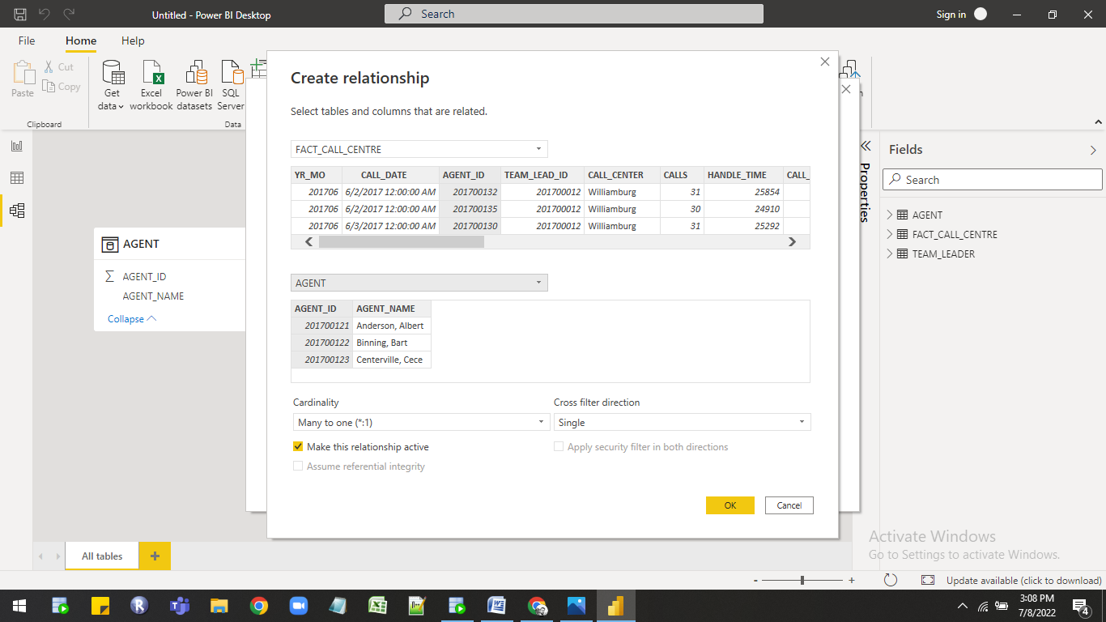

  9)  Proper data model is created you can see in the image.

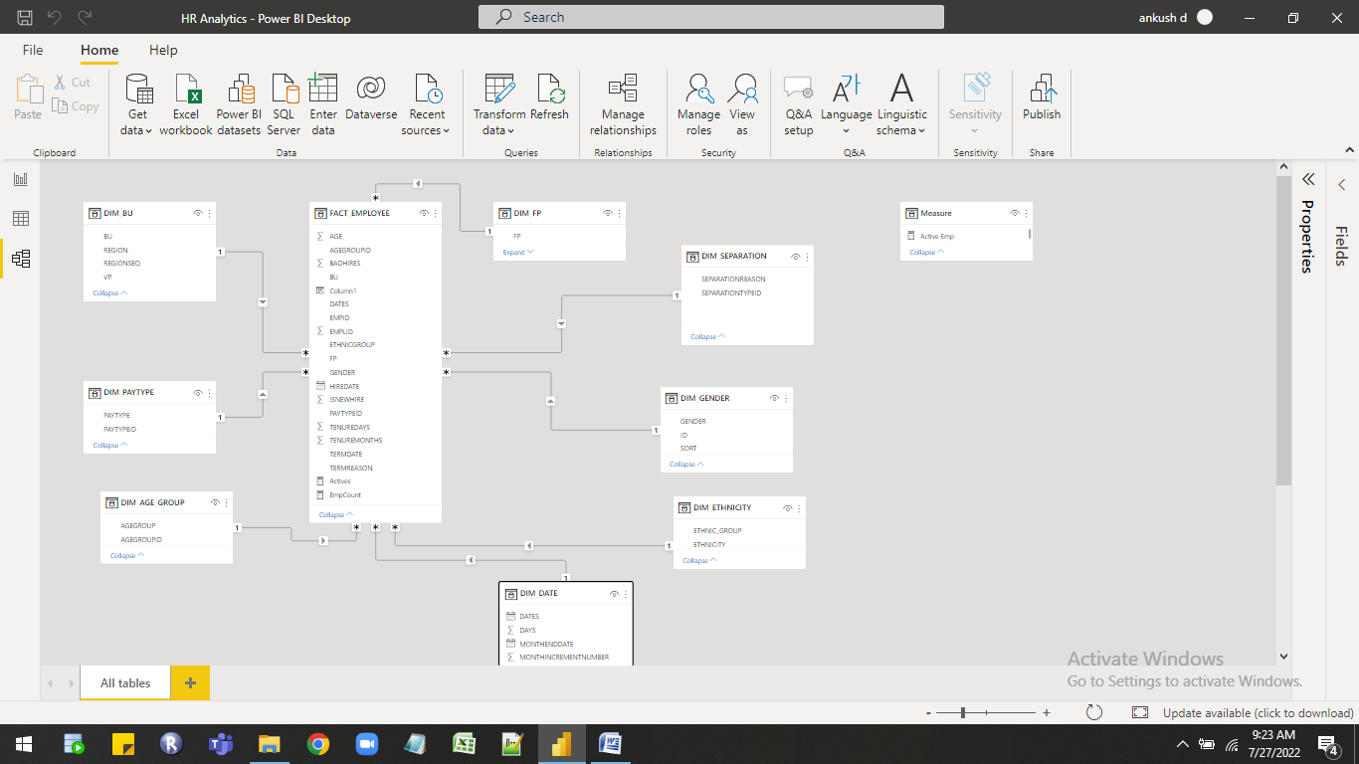

**Business Requirements:-**

## Following are the requirements

|  |  |  |  |  |  |
| --- | --- | --- | --- | --- | --- |
| **BUSINESS REQUIREMENT** | | | | | |
| 1 | HR Management Dashboard | | **Hires**   * Active Employees * Male Active Employees * Female Active Employees * Male Active Employees % * Female Active Employees% * Active employees by experience in years * Active employees by Age group   **Bad Hires**   * Total Bad Hired * Male bad hire and its % * Male bad hire and its % * Bad Hire by age group   **New Hiring**   * New Hired * Male Hired and its % * Female Hired and its% * New Hire by age group   **Attrition**   * Total attrition * Voluntary attrition * Involuntary attrition   **Ethnicity**   * Avg Tenure Months by age group * How many bad hires by Ethnicity. | High | |
| 2 | HR Headcount Trend (u can show hire and attrition analysis separate as well)  trend should have comparison between current year and previous year.  Just like Current Month vs Previous Month and Current Year vs Previous Month and its change % | | * Total Active Employees Monthly/Quarter * Total Hire Employees by Month/Quarter * Year filter for selection of any required year * There should be toggle or change option if I want to see monthly data then will click on it and same for quarter view.   (Month should be like – Jun-22 and Quarter should be like Q1-22) | Medium | |
| 3 | Attrition Analysis | | * Total Attrition * How many people left by gender? * How many people left by experience? * How many people left by age group? * How many people left for different regions? * Against different job type how many people left? * How many hourly paid people left? * How many Salaried people left? * Attrition % Monthly trend * Provide Year, Region and Gender Trend * Also provide detail of the left people if I want to know detail of the left person there should be drill option to get entire details. | High | |
|  | |  | | | High |

**KPI’s**

* + Active Employees
  + Male Active Employees
  + Female Active Employees
  + Male Active Employees %
  + Female Active Employees%
  + Active employees by experience in years
  + Active employees by Age group
* New Hired
* Male Hired and its %
* Female Hired and its%
* New Hire by age group
  + Total attrition
  + Voluntary attrition
  + Involuntary attrition

## Required Calculation

For creating report required DAX calculation are as follow

| Sr.No | Dax Measure |
| --- | --- |
| 1 | Actives = CALCULATE([EmpCount], FILTER(fact_Employee, ISBLANK(fact_Employee[TermDate]))) |
| 2 | EmpCount = (distinctCOUNT([EmplID])) |
| 3 | Diff in Years = DATEDIFF(FACT_EMPLOYEE[HIREDATE],FACT_EMPLOYEE[DATES],YEAR) |
| 4 | Actives SPLY = CALCULATE([Actives],SAMEPERIODLASTYEAR('DIM_DATE'[DATES])) |
| 5 | Total Tenure months = sum(FACT_EMPLOYEE[TENUREMONTHS]) |
| 6 | total badhires = calculate(Count(FACT_EMPLOYEE[Bad_Hire]),FACT_EMPLOYEE[Bad_Hire]=1) |
| 7 | Total attrition = COUNT(FACT_EMPLOYEE[TERMDATE]) |
| 8 | New Hired = sum(FACT_EMPLOYEE[ISNEWHIRE]) |
| 9 | New Hire SPLY = CALCULATE([New Hired],SAMEPERIODLASTYEAR('DIM_DATE'[DATES])) |

## Report Building :-

As per the requirements next steps is to create report with multiple pages. For creating report the following are the components are used in this report.

Pages In the Report:-

1.Home page:-

Visualization

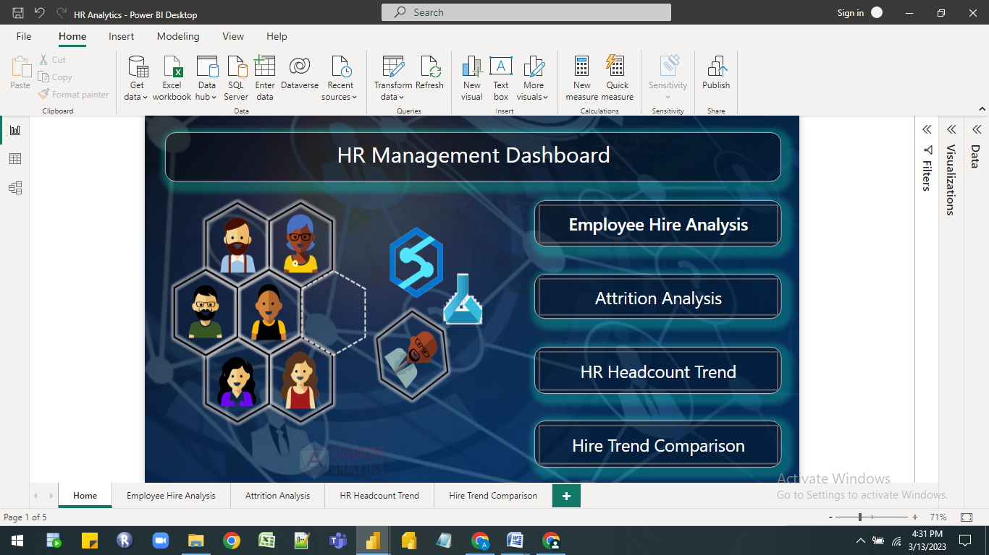

Feature Used in report

| 1 | Page Navigation |
| --- | --- |
| 2 | Button |
| 3 | Logo,Image |
| 4 | Tooltip |

2.Employee Hire Analysis:-

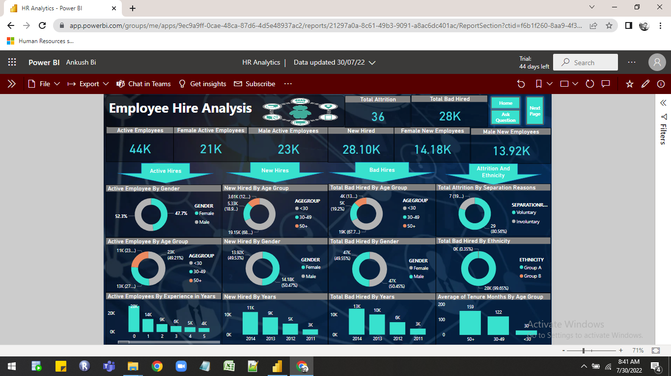

Visualization List

| 1 | Cards |
| --- | --- |
| 2 | Column Chart |
| 3 | Donut Chart |

Feature Used in report

| 1 | Page Navigation |
| --- | --- |
| 2 | Slicer |
| 3 | Button |
| 4 | Logo,Image,Sticker |

3.Attrition Analysis:-

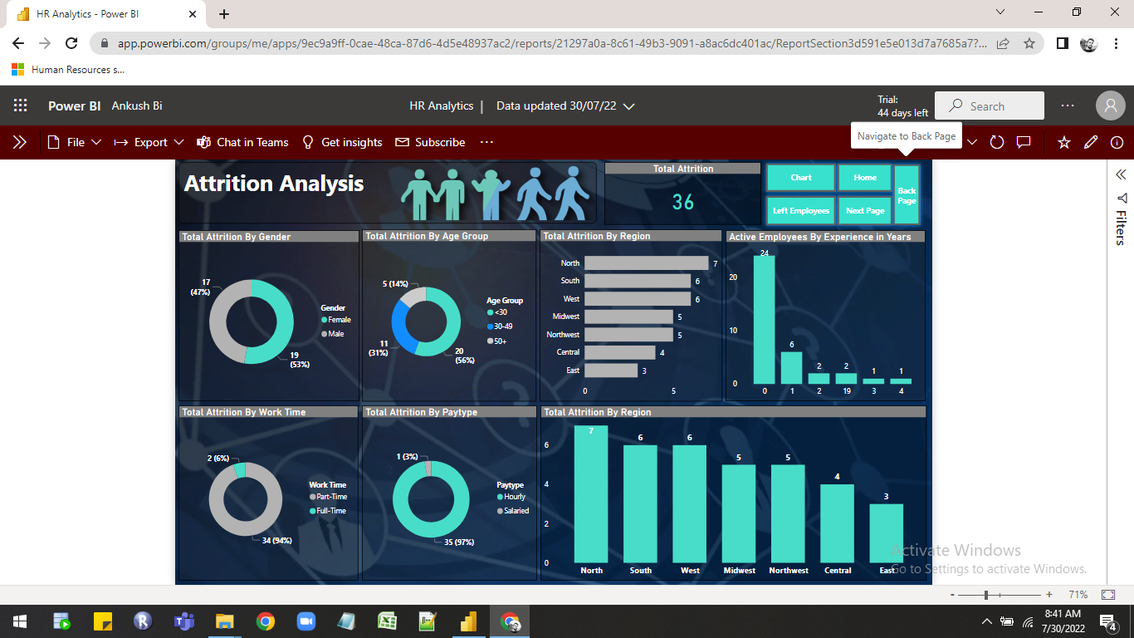

Visualization List

| 1 | Cards |
| --- | --- |
| 2 | Bar Chart |
| 3 | Column Chart |
| 4 | Donut Chart |

Feature Used in report

| 1 | Page Navigation |
| --- | --- |
| 2 | Tooltip |
| 3 | Button |

4.HR Headcount Trend:-

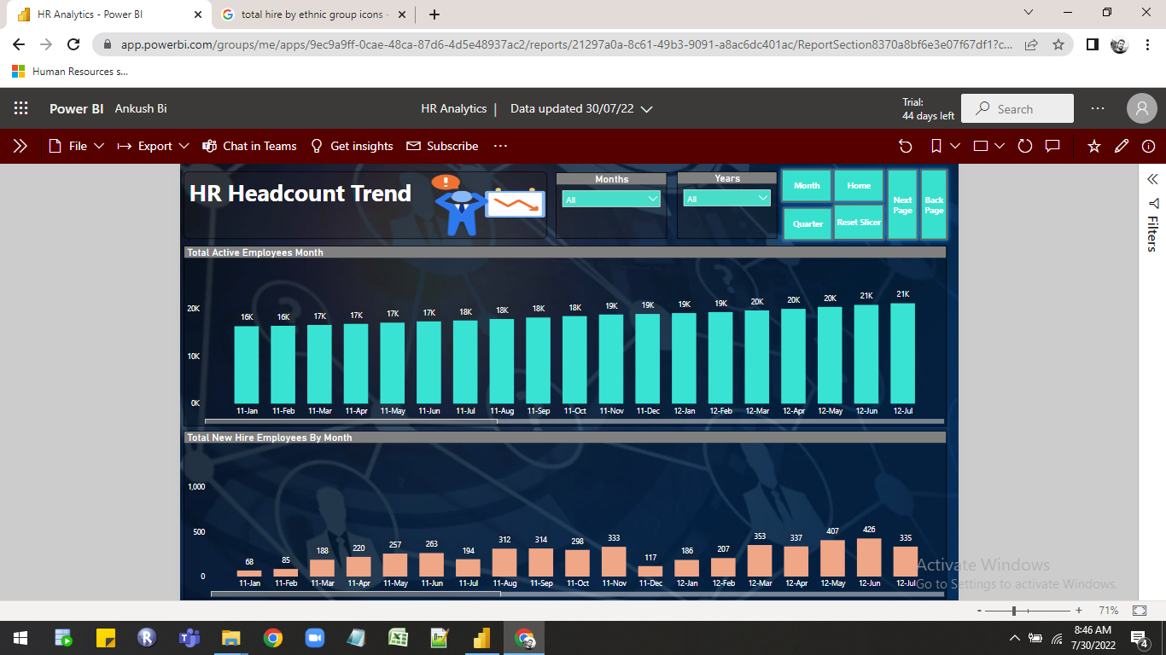

Visualization List

| 1 | Cards |
| --- | --- |
| 2 | Slicer |
| 3 | Column Chart |

Feature Used in report

| 1 | Page Navigation |
| --- | --- |
| 2 | Tooltip |
| 3 | Button |
| 4 | Sticker |

5) Hire Trend Comparison :-

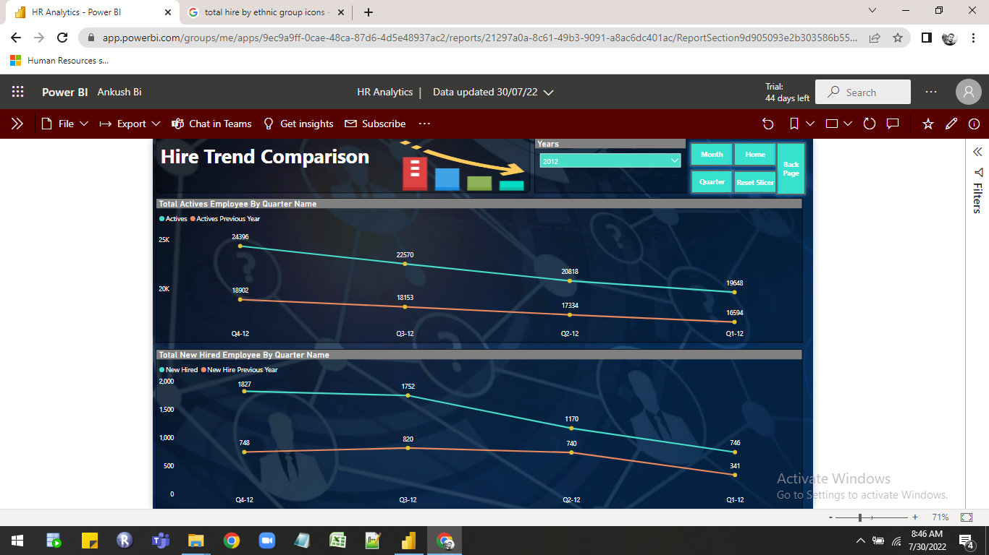

Visualization List

| 1 | Line Chart |
| --- | --- |
| 2 | Slicer |

Feature Used in report

| 1 | Page Navigation |
| --- | --- |
| 2 | Tooltip |
| 3 | Button |
| 4 | Sticker |